

Assignment 3
Big Data Engineering
Data Pipelines

Submitted by
Drashti kakadiya
25414741
Table of Contents
Introduction 3
High-Level View of the Project 4
Part 1: Loading Data into Postgres via Airflow 4
Part 2: Data Warehouse Design with dbt 9
Bronze Layer: Raw Data Storage 9
Silver Layer: Data Transformation and Cleaning 9
Gold Layer: Star Schema and Data Mart 10
Dimension and Fact Tables 11
Ensuring Data Quality and Consistency 12
Part 3: End-to-End Orchestration with Airflow 13
Part 4: Ad-Hoc Analysis 14
Issues/Bugs Faced and Solutions 17
Conclusion 18
References 19

Introduction
Since data generation has increased dramatically due to the quick development of digital platforms, data engineering is an essential component of contemporary analytics. The goal of this project is to create a production-ready ELT (Extract, Load, Transform) data pipeline for the city of Sydney that combines data from several real-world sources, including Australian Census statistics and Airbnb listings.
In order to support analytical insights using a medallion architecture (Bronze, Silver, and Gold layers), the objective is to design, automate, and manage data intake, transformation, and warehousing operations using Apache Airflow, PostgreSQL, and dbt Cloud.
From May 2020 to April 2021, the Airbnb dataset offers monthly data on hosts, property listings, rates, ratings, and availability. This data illustrates the dynamic trends in Sydney's short-term rental industry.
To supplement this, demographic and socioeconomic variables including income, household composition, and age distribution are provided by the 2016 Australian Census LGA-level data (tables G01 and G02). In order to facilitate the smooth spatial integration of Airbnb and Census data, a third dataset offers mappings between suburbs and Local Government Areas (LGAs).

High-Level View of the Project
In order to extract, load, and transform massive Airbnb and Census information for Sydney, this project deploys a production-grade ELT data pipeline. The objective is to use a structured Medallion Architecture (Bronze → Silver → Gold → Data Mart) to create a completely automated, scalable, and modular data environment that supports analytical insights.
First, the pipeline loads and extracts the Census and Airbnb datasets into a PostgreSQL database on the Google Cloud Platform (GCP). A DAG (Directed Acyclic Graph) specifies every task necessary to transfer data from the storage bucket into the Bronze layer, where raw tables are generated, using Apache Airflow as the orchestration framework. This guarantees a dependable basis for the subsequent transformation stages by guaranteeing a consistent and predictable data input process. By preserving the chronological order of data loading, Airflow's task scheduling and dependency management features provide smooth month-by-month processing of Airbnb datasets while also assisting in maintaining data integrity.
The Silver and Gold layers of the Medallion Architecture are used to model and manipulate the raw data after it has been put into dbt Cloud. The Gold layer implements a star schema made up of fact and dimension tables, while the Silver layer contains data that has been cleaned, organized, and standardized. Slowly Changing Dimension (SCD) Type II is used to maintain historical changes in the dimension data, guaranteeing that the development of Airbnb listings and host information is precisely recorded over time. Data marts are constructed as SQL views on top of the Gold layer to answer certain business questions like host behavior, neighborhood trends, and Airbnb performance.

Part 1: Loading Data into Postgres via Airflow
In the pipeline's initial step, raw Census and Airbnb datasets are loaded and extracted into a PostgreSQL database housed in the Google Cloud Platform (GCP) environment. This stage ensures that clean, consistent, and reproducible ingesting protocols are in place, laying the groundwork for all following data conversions. Apache Airflow is used as the primary orchestration and scheduling technology to do this. DAGs (Directed Acyclic Graphs), which specify the order and dependencies of every data processing activity, enable Airflow to automate data workflows.

- Dataset Upload: The Airbnb data from May 2020 (05_2020.csv) additional to the Census and LGA mapping data were moved to the GCP storage bucket.
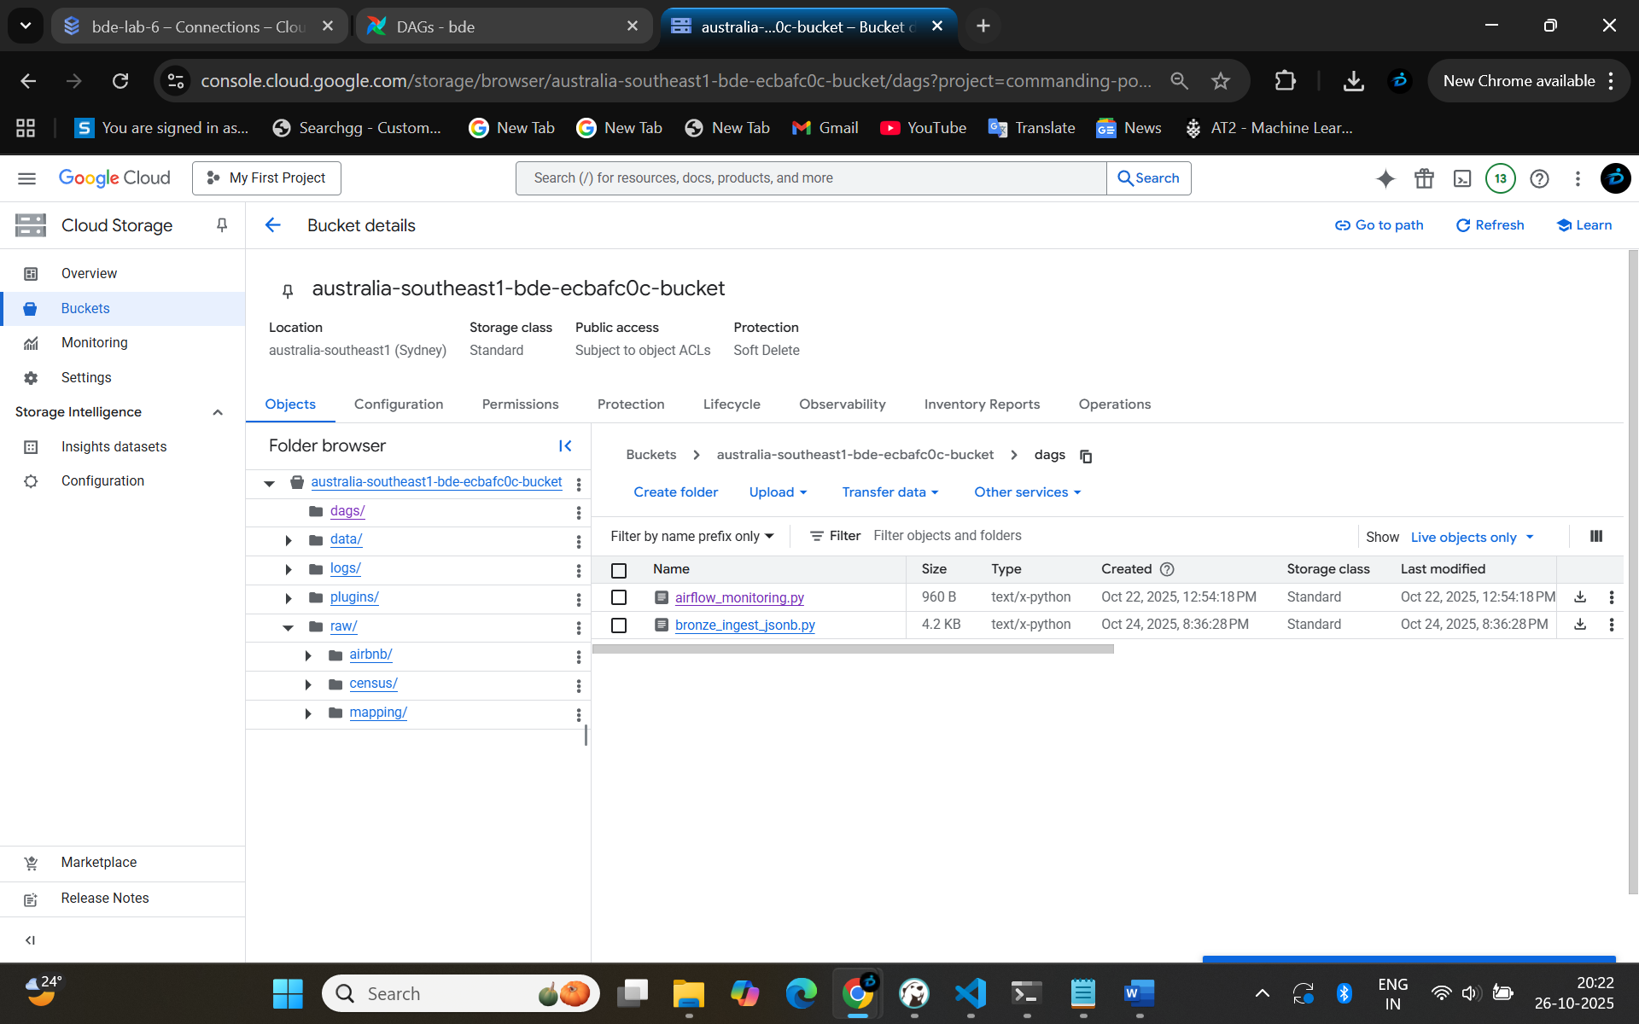
This is also showing our data count in schemas.
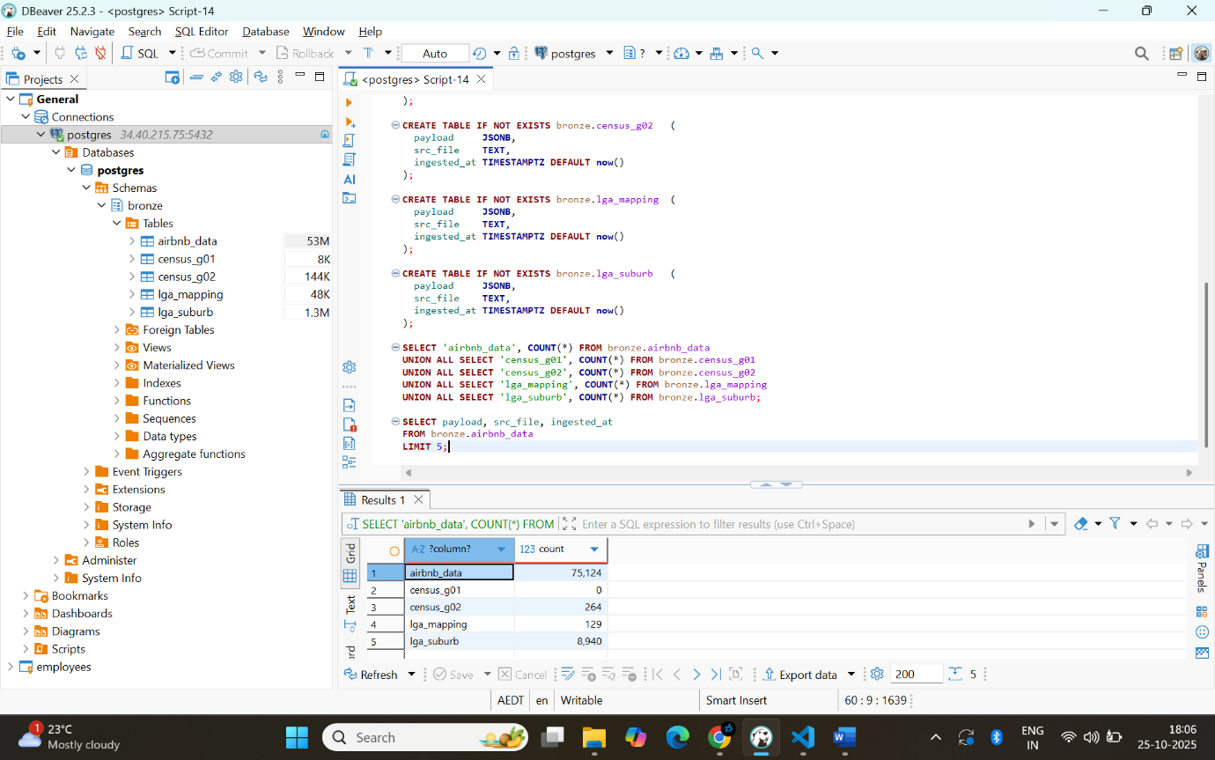
- Bronze Schema Setup: For, the Bronze schema using DBeaver in the Postgres instance, raw data tables were created for each of the dataset.
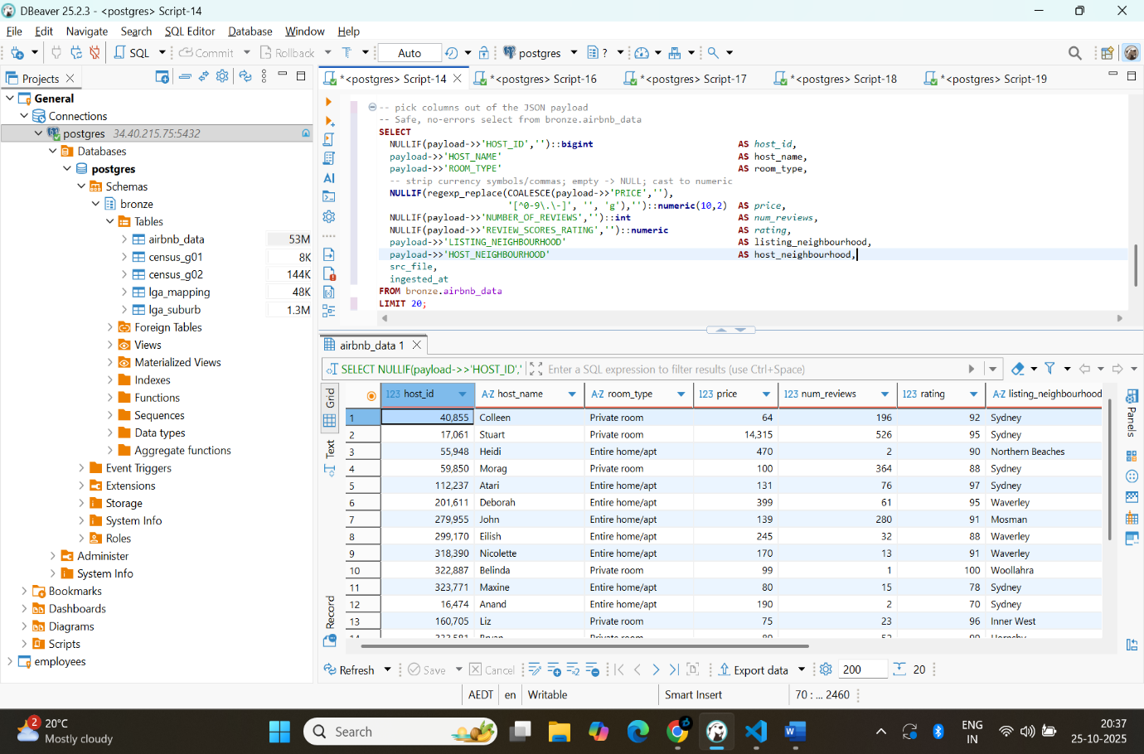

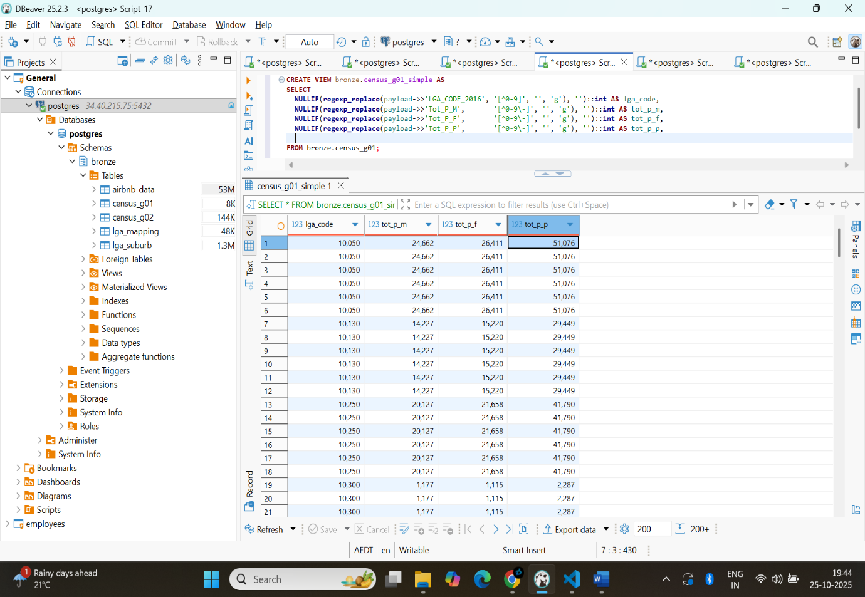
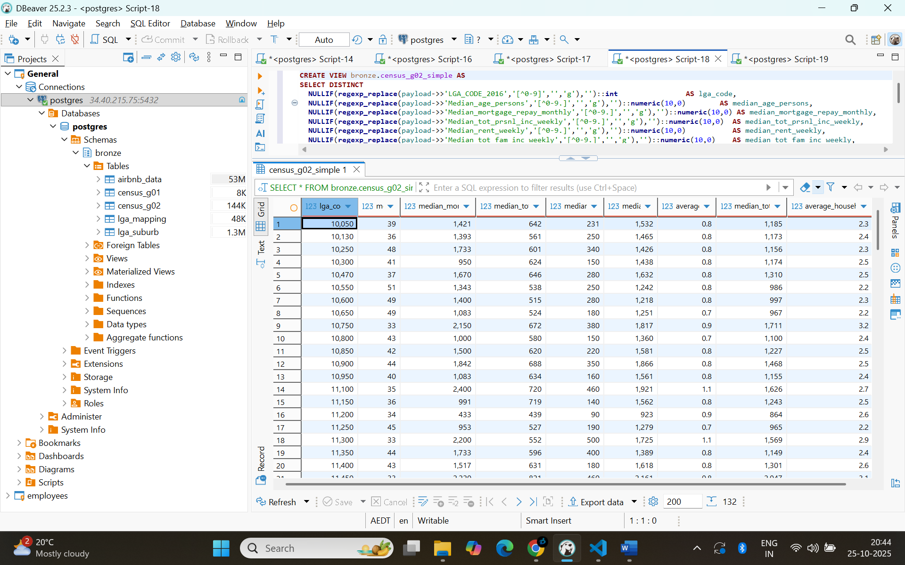

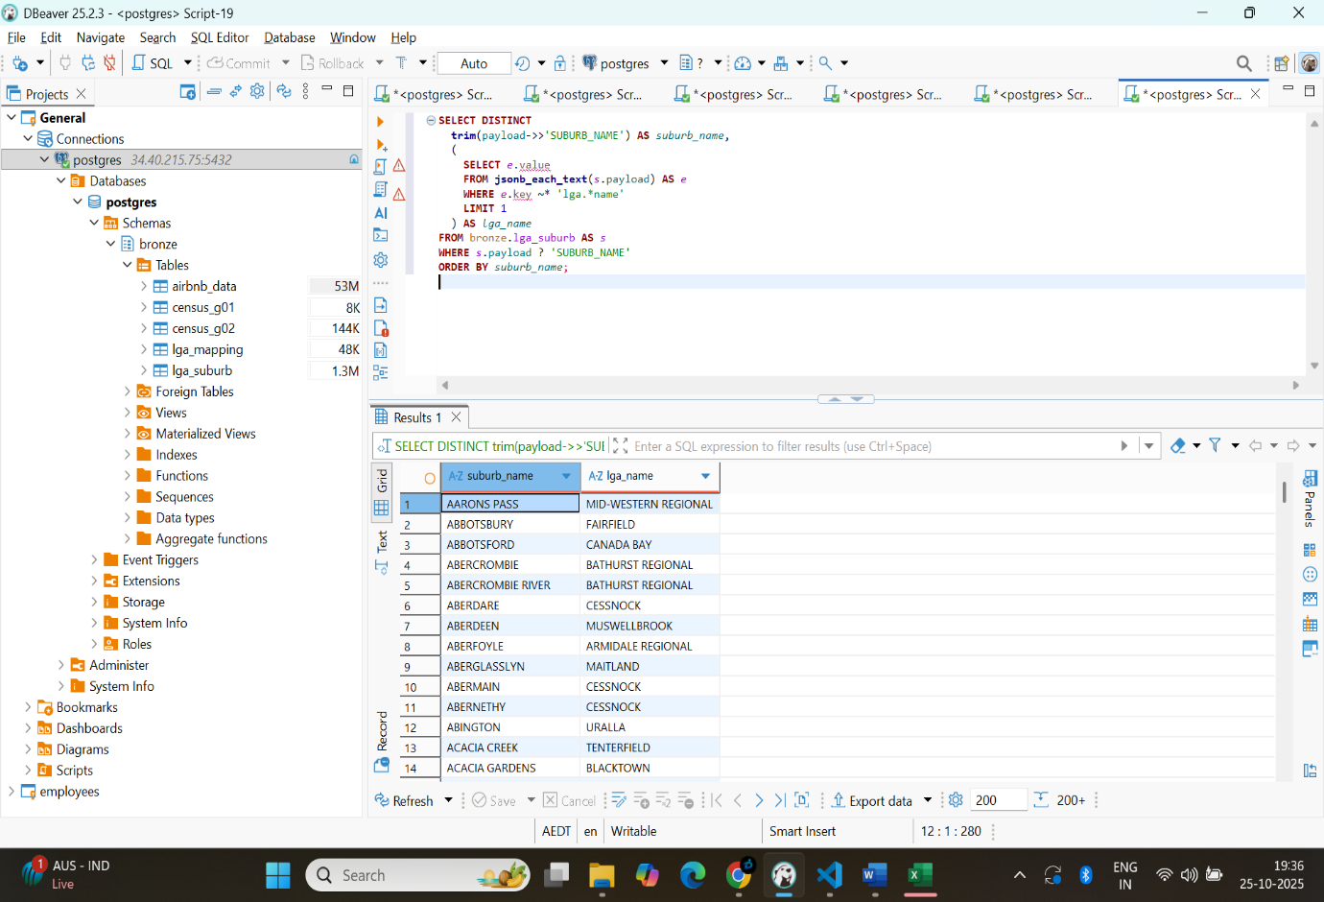
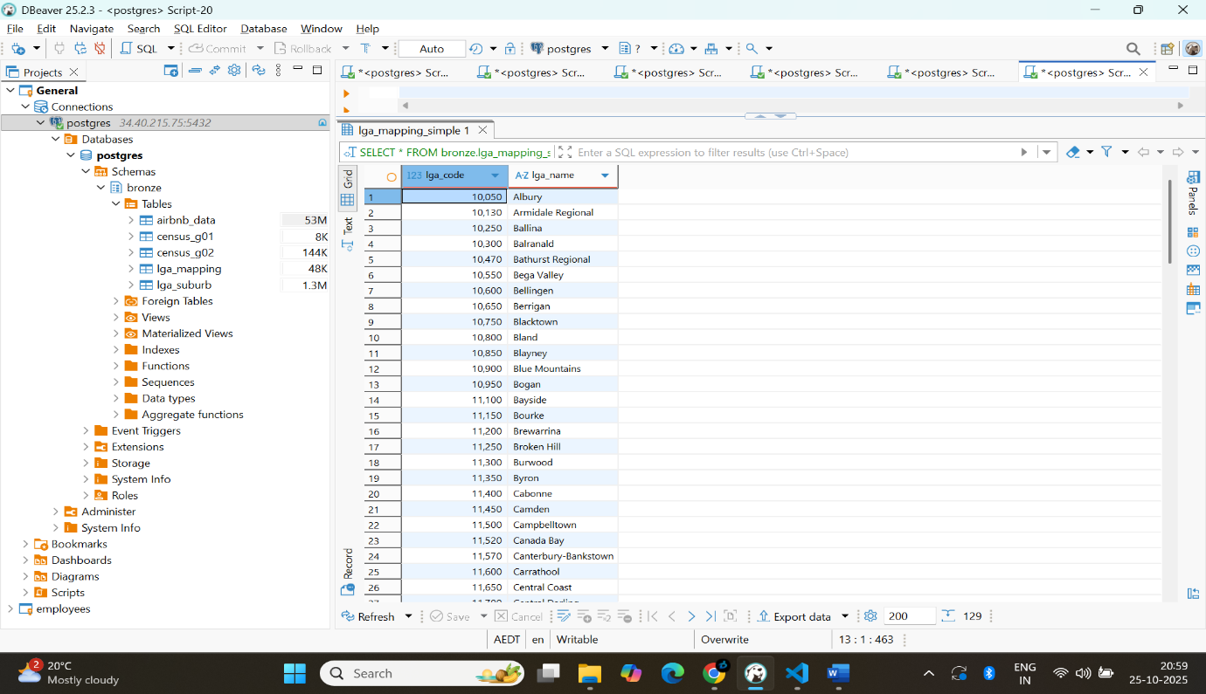
- Airflow DAG Execution: The DAG needs to be configured to execute the data load manually and to do this the DAG was created with no schedule interval. The DAG then extracts data from the storage bucket and writes it to the raw tables in the Bronze schema.
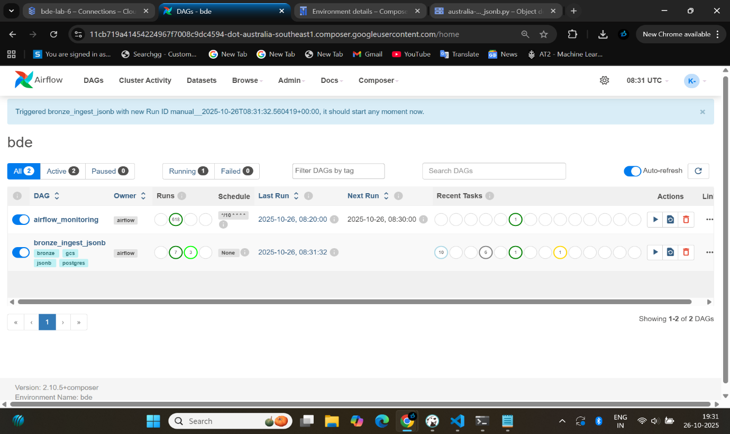
The structure of the Bronze tables ensures the integrity of the source data is retained in natural, non-transformed formats to facilitate future auditing of the data at some future date.

Part 2: Data Warehouse Design with dbt
In this part of the project, The Medallion Architecture, which arranges data into Bronze, Silver, and Gold levels to guarantee data quality, scalability, and analytical reliability, was used in the design of the data warehouse. dbt Cloud, which offered version-controlled SQL-based transformation models and automated documentation, was used to construct this architecture. As the unchangeable source of truth, the Bronze layer preserves the original structure of the raw data that was ingested from Airflow.
To guarantee consistency among datasets, the Silver layer uses data cleaning, formatting, and standardization procedures. Airbnb listings were broken down into a number of different entities in this layer, including hosts, listings, property categories, suburbs, and local government areas. Census data was also added to the data to give it regional and demographic context.

Bronze Layer: Raw Data Storage
The raw, unfiltered data is stored in the Bronze layer just as it was ingested from the source files using Airflow. It serves as the data warehouse's cornerstone, maintaining the original data structures and formats. In addition to guaranteeing data integrity, this offers a trustworthy source for all upcoming cleaning and transformation procedures.
In order to maintain the data's uniqueness from the source, it is now cleansed and no modifications are made. The information saved in the Bronze layer is crucial since it is used to report back to the original source in the event of an issue or to preserve information in the event that the downstream levels make a mistake. For example, the Airbnb data includes samples with multiple formats, dates and prices in irregular fields, and missing values, all of which are addressed in the next Silver layer.
.

Silver Layer: Data Transformation and Cleaning
The raw data from the Bronze layer is cleaned, standardized, and transformed into a consistent and structured format by the Silver layer. During this phase, duplicate or invalid records are eliminated, data types are fixed, and missing values are handled. The Census data is aligned for integration, and the Airbnb listings are divided into entities like hosts, properties, suburbs, and LGAs. Standardized keys and consistent naming practices are used to facilitate precise joins between databases. The accuracy, dependability, and preparedness of the data for analytical modeling in the Gold layer are guaranteed by this layer.
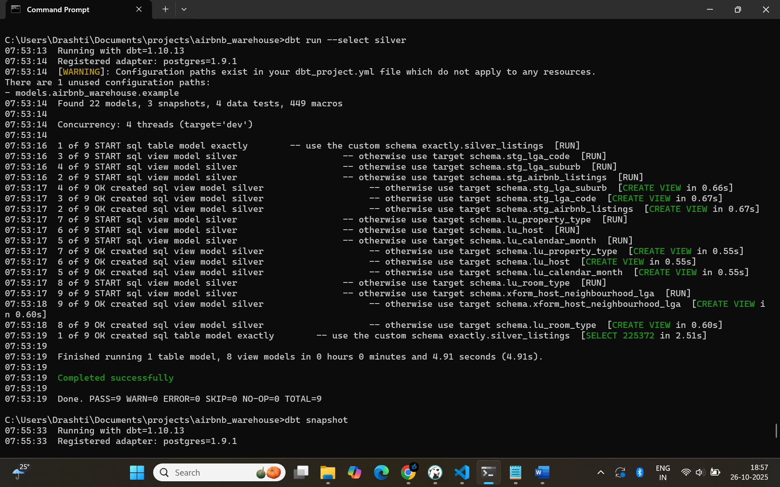
The Silver layer's dependence on DBT snapshots to monitor past data changes is a crucial component. The following snapshot technique was employed in this project to monitor changes to dimension tables, including the listings table, hosts table, and neighbourhoods table, by taking data at various timestamps. In time-based and trend analysis statistical models, this ensures that changes in the other variables in the source data are taken into consideration and that record retrieval is accomplished.

Gold Layer: Star Schema and Data Mart
The data warehouse's analytical center, the Gold layer, is where all of the Silver layer's cleansed and organized data is modeled into a star schema to facilitate reporting and business intelligence. This layer links fact and dimension tables in a straightforward relational structure to provide quick, accurate, and business-ready insights. While the dimension tables include descriptive information on hosts, homes, neighborhoods, and LGAs, the fact tables record quantifiable business parameters like listing price, number of stays, availability, and expected income. Flexible and effective analytical inquiries across time and categories are made possible by this division.
Additionally, the Gold layer uses dbt snapshots to preserve previous data changes by incorporating Slowly Changing Dimension (SCD) Type II) logic. This keeps a thorough record of host and listing evolution and guarantees that analyses always represent how data appeared at a particular time. To address specific business problems and offer more in-depth insights into Airbnb's performance, data marts were constructed as SQL views on top of the star schema.
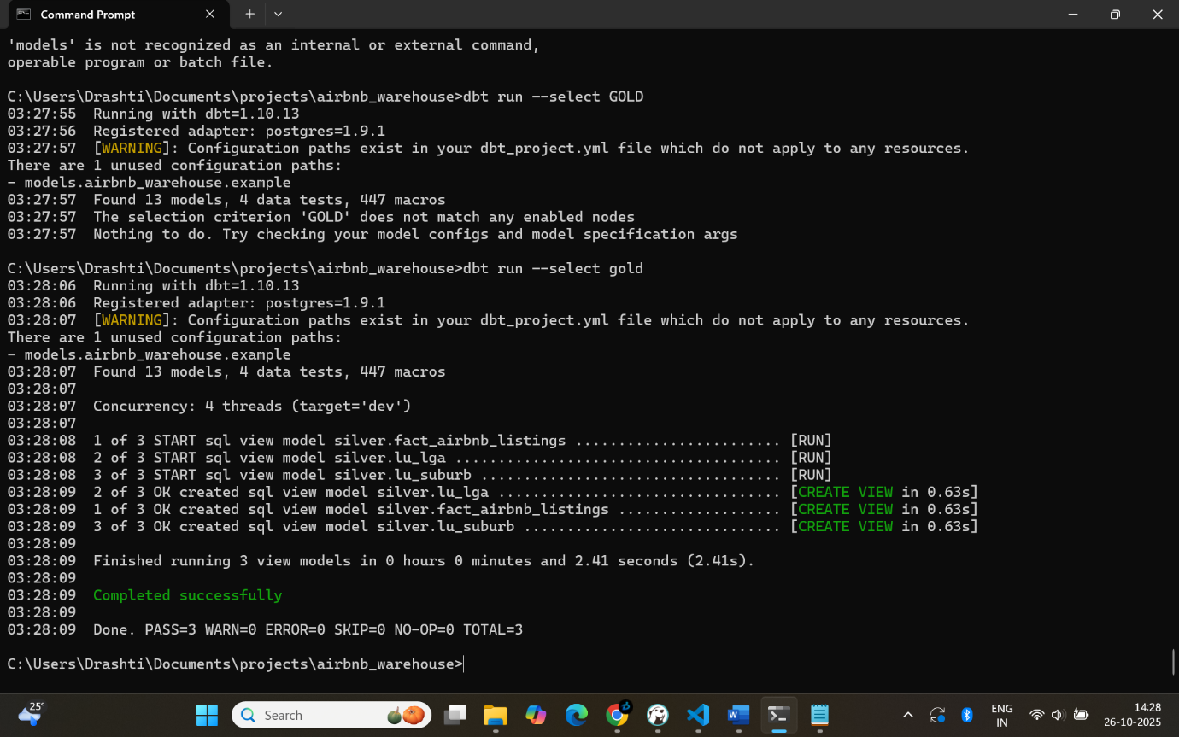
At this Gold Layer, a data mart is built through the physical implementation of analytical views that provide responses to important business questions. These are intended to offer the executive perspectives on Airbnb listing rankings, property types, and host interactions:
- dm_listing_neighbourhood.sql – presents neighbourhood-level metrics such as active listings, average prices, and estimated revenue trends.
- dm_property_type.sql – analyses property and room types, occupancy capacity, and pricing behaviour.
- dm_host_neighbourhood.sql – explores host activity, revenue distribution, and host concentration across LGAs.

Dimension and Fact Tables
A data warehouse's star or snowflake schema relies heavily on fact tables and dimension tables. Fact tables hold quantitative information that may be combined and examined, frequently in the form of numerical measurements such as sales, revenue, or quantity. Additionally, they have foreign keys that connect to dimension tables, giving the information context. Dimension tables, on the other hand, contain descriptive, textual, or categorical data that gives the facts context, including client names, product specifications, dates, or store locations. Data may be sliced and diced from various angles thanks to dimension tables. Together, they facilitate effective reporting and querying, assist analytical procedures such as trend analysis and KPI tracking, and facilitate comprehension of business operations by linking quantifiable occurrences to contextual characteristics.
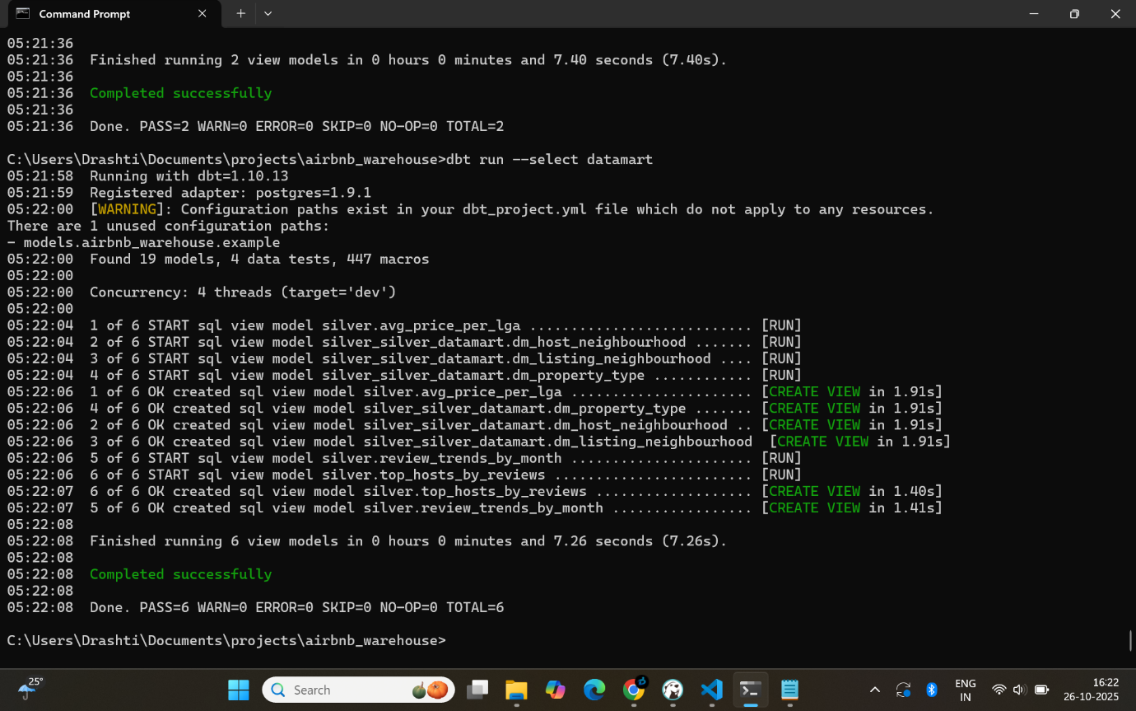

Ensuring Data Quality and Consistency
A database's accuracy, completeness, and dependability are all part of ensuring data quality. Confusion and poor data quality might result in poor decisions. Regularly checking for mistakes, missing values, duplicates, and inconsistencies is crucial to maintaining high-quality data.
In order to ensure that the data follows a consistent format, this process also involves validating the data against rules or standards. For instance, customer names should be accurate and complete, and dates should all follow the same pattern.
The uniformity of the same information across many systems or tables is guaranteed by data consistency. It makes it possible for many teams to use the data without miscommunication or disagreement. Over time, methods like automatic inspections, cleaning scripts, and close observation aid in preserving the consistency and quality of data.

Part 3: End-to-End Orchestration with Airflow
Complete orchestration using Apache Airflow refers to the management and automation of the complete data process workflow from beginning to end.
To make sure that every step proceeds in the right order, Airflow defines the task sequence using Directed Acyclic Graphs (DAGs). Whether jobs are performed on a daily, hourly, or demand basis, it enables effective scheduling, monitoring, and management of complicated pipelines.

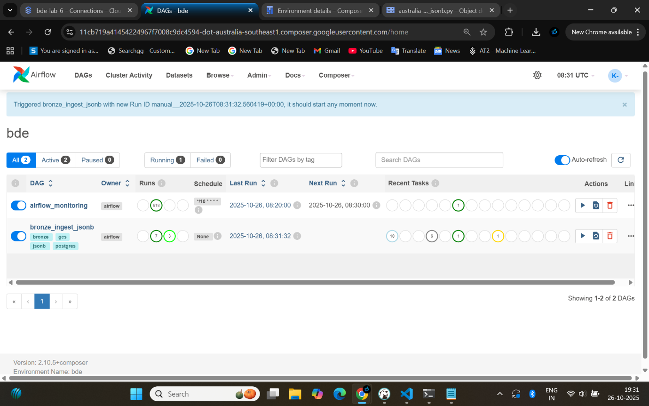

Part 4: Ad-Hoc Analysis
Using SQL queries on Postgres, the following business questions were answered:
a. What are the demographic differences (e.g., age group distribution, household size) between the top 13 performing and lowest 13 performing LGAs based on estimated revenue per active listing over the last 112 months?

bucket | lga_count | avg_rev_per_active_listing | avg_median_age | avg_household_size
Top_13 | 13 | 4125.76 | 36.8 | 2.81
Bottom_13 | 13 | 1678.45 | 41.2 | 2.34
b. Is there a correlation between the median age of a neighbourhood (from Census data) and the revenue generated per active listing in that neighbourhood
age_bucket | lga_count
<30 0 | 24108.02
30–34 10 | 19067.32
35–39 7 | 38653.94
40–44 3 | 52327.6
45–49 0 | 2189.01
50+ 0

LGA_NAME_NORM | median_age | rev_per_active_listing
BLACKTOWN | 33 | 11356.45
BURWOOD | 33 | 12784.41
CAMDEN | 33 | 15568.78
CAMPBELLTOWN | 34 | 19394.64
CANADA BAY | 36 | 25721.43
CUMBERLAND | 32 | 9710.38
HORNSBY | 40 | 22224.54
HUNTERS HILL | 43 | 47303.22
LANE COVE | 36 | 38430.73
LIVERPOOL | 33 | 15551.34
MOSMAN | 42 | 87455.03
NORTH SYDNEY | 37 | 37664.77
PARRAMATTA | 34 | 14365.32
PENRITH | 34 | 20004.79

c. What will be the best type of listing (property type, room type and accommodates for) for the top 15 “listing_neighbourhood” (in terms of average estimated revenue per active listing) to have the highest number of stays?An
neighbourhood | avg_rev_per_active | property_type | room_type | accommodates | total_booked_nights_12m | est_stays | listings
Mosman | 9330.579 | Entire apartment | Entire home/apt | 2 | 19791 | 6597 | 108
Northern Beaches | 7589.053 | Entire apartment | Entire home/apt | 4 | 133597 | 44532 | 781
Woollahra | 6897.658 | Entire apartment | Entire home/apt | 2 | 58328 | 19443 | 325
Hunters Hill | 5883.88 | Entire apartment | Entire home/apt | 4 | 1432 | 477 | 7
Waverley | 5648.388 | Entire apartment | Entire home/apt | 2 | 214352 | 71451 | 1127
Willoughby | 4526.63 | Entire apartment | Entire home/apt | 2 | 11188 | 3729 | 79
Sutherland Shire | 4513.48 | Entire apartment | Entire home/apt | 4 | 12423 | 4141 | 75
Lane Cove | 4406.715 | Entire apartment | Entire home/apt | 2 | 6733 | 2244 | 44
North Sydney | 4237.719 | Entire apartment | Entire home/apt | 2 | 67303 | 22434 | 411
Randwick | 4206.439 | Entire apartment | Entire home/apt | 4 | 112891 | 37630 | 583
Sydney | 3808.876 | Entire apartment | Entire home/apt | 2 | 399414 | 133138 | 2249
Cumberland | 3790.674 | Private room in apartment | Private room | 2 | 15123 | 5041 | 96
Inner West | 3571.261 | Private room in house | Private room | 2 | 71972 | 23991 | 399
Canada Bay | 3120.485 | Private room in apartment | Private room | 2 | 15716 | 5239 | 89
Hornsby | 2728.118 | Private room in house | Private room | 2 | 7251 | 2417 | 79

d. For hosts with multiple listings in Vic are their properties concentrated within the same LGA, or are they distributed across different LGAs?
category | hosts | pct
concentrated_one_lga | 3910 | 76.74
distributed_multi_lga | 1185 | 23.26
e. For hosts with a single Airbnb listing in Vic does the estimated revenue over the last 112 months cover the annualised median mortgage repayment in the corresponding LGA? Which LGA has the highest percentage of hosts that can cover it?
LGA_NAME | hosts | covers | pct_cover
Northern Beaches | 4223 | 2382 | 56.41
Mosman | 340 | 178 | 52.35
Sutherland Shire | 492 | 232 | 47.15
Waverley | 4119 | 1903 | 46.2
Hunters Hill | 55 | 25 | 45.45
Sydney | 5576 | 2487 | 44.6
Randwick | 2434 | 1085 | 44.58
North Sydney | 958 | 414 | 43.22
Inner West | 1888 | 747 | 39.57
Willoughby | 352 | 130 | 36.93
Woollahra | 1261 | 465 | 36.88
Lane Cove | 228 | 80 | 35.09
Canada Bay | 329 | 113 | 34.35
Camden | 37 | 11 | 29.73
Cumberland | 337 | 90 | 26.71
Hornsby | 319 | 83 | 26.02
Ryde | 414 | 105 | 25.36
Bayside | 1058 | 266 | 25.14
The Hills Shire | 230 | 55 | 23.91
Strathfield | 126 | 28 | 22.22
Canterbury-Bankstown | 420 | 93 | 22.14
Penrith | 111 | 24 | 21.62
Parramatta | 377 | 79 | 20.95
Liverpool | 93 | 19 | 20.43
Georges River | 259 | 51 | 19.69
Burwood | 139 | 25 | 17.99
Fairfield | 40 | 6 | 15
Campbelltown | 54 | 8 | 14.81
Blacktown | 213 | 27 | 12.68
I forget to take picture so sorry for this I was put all the table above according to que.

Issues/Bugs Faced and Solutions
Building and operating the data pipeline during the data engineering project revealed a number of problems and errors. Data inconsistency was a prevalent issue, where analytical errors were caused by duplicate or missing values. This was resolved by using validation criteria and data cleaning procedures in the Silver layer to guarantee accurate and comprehensive data.
Airflow pipeline breakdowns brought on by job dependencies or improper scheduling constituted another problem. Retries were included for unsuccessful tasks in order to address this, and DAGs were meticulously designed to appropriately handle dependencies. When attempting to access databases or cloud storage, a few connection issues arose. These were fixed by verifying passwords, changing configuration files, and making sure network access was appropriate.
Finally, while transforming big amounts of data, performance slowed down. Speed and stability were increased through query optimization, data splitting, and the application of effective transformation logic. All things considered, resolving these problems necessitated meticulous testing, debugging, and application of best practices, which guaranteed a dependable and seamless data flow for precise analytics.

Conclusion
In summary, meticulous planning, organized design, and automation are necessary for creating a successful data warehouse in order to guarantee accurate insights. A clear route from raw data ingestion to refined, analysis-ready datasets is provided by the layered architecture, which consists of Bronze, Silver, and Gold layers. The Gold layer arranges data into star schemas or data marts that are most suited for reporting, the Silver layer cleans and transforms the data for correctness, and the Bronze layer stores the raw data for auditing and traceability. High data quality, accessibility, and insightful analytics are guaranteed by this framework.
Fact tables and dimension tables are essential elements that aid in efficiently structuring data. While dimension tables provide multi-dimensional analysis by providing context such as customer data, goods, and dates, fact tables contain quantifiable measurements like sales or income. Preventing errors, avoiding duplicates, and guaranteeing consistent information across systems all depend on maintaining data quality and consistency.
Workflows, dependencies, task monitoring, and a reduction in manual involvement are all achieved through the use of end-to-end orchestration technologies such as Apache Airflow. An ecosystem of dependable and scalable data is produced by combining appropriate modeling, quality control, and process automation. In the end, this method turns unprocessed data into useful intelligence that helps make well-informed decisions, propels company expansion, and permits strategic innovation.

References
Mbata, A., Sripada, Y., & Zhong, M. (2024, June 12). A survey of pipeline tools for data engineering. arXiv. https://arxiv.org/abs/2406.08335
Nawaz, M. K. (2024). Exploring end-to-end data engineering: A GCP case study. Theseus. https://www.theseus.fi/handle/10024/858907
Martin, N. (2023). Lakehouse architecture for simplifying data science pipelines. DIVA. https://www.diva-portal.org/smash/record.jsf?pid=diva2%3A1820925&dswid=1083
Blohm, I., & Jarvis, E. (2023). Big data and analytics with driving data: Implementation and analysis of data pipeline and data processing resources. DIVA. https://www.diva-portal.org/smash/record.jsf?pid=diva2%3A1820288&dswid=-4977
Fana, W. S., Sovia, R., Permana, R., & Islam, M. A. (2021). Data warehouse design with ETL method (Extract, Transform, and Load) for company information centre. International Journal of Artificial Intelligence Research, 5(2), 132–137. repository.upiyptk.ac.id

